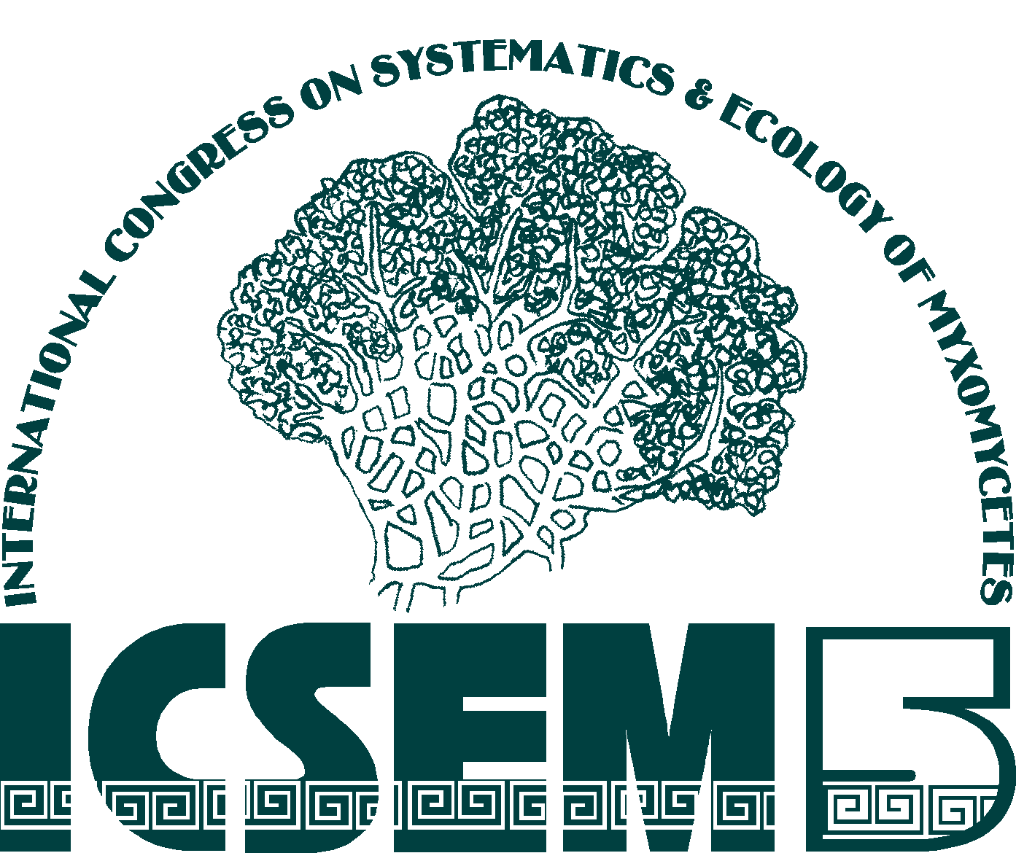

5th INTERNATIONAL CONGRESS ON THE SYSTEMATICS AND ECOLOGY OF MYXOMYCETES

TLAXCALA, MEXICO, AUGUST 8-13, 2005

Scientific Program
Programa Científico

SYNOPTIC SCIENTIFIC PROGRAM OF THE ICSEM-5

 | Sunday  7th August | Monday  8th August |  |  | Tuesday  9th August |  | Wednesday  10th August |  | Thursday  11th August |  | Friday  12th August
9.00-9.30 | Pre-congress mini-courses 2 and 3 | Pre-congress mini-courses 1, 2 and 3 |  | Plenary session: Prof. Dr. James C. Cavender, Ohio University |  | Oral session: Mycetozoan Biodiversity |  | Congress foray to the temperate forests of the Sierra de Tlaxco |  | Oral session: Perspectives on Phylogenetic Systematics of Mycetozoans
9.30-10.00
10.00-10.30 | Pre-congress mini-courses 2 and 3 | Pre-congress mini-courses 1, 2 and 3 | Registration and enrolment  Mounting of the posters | Break
10.30-11.00 | Pre-congress mini-courses 2 and 3 | Pre-congress mini-courses 1, 2 and 3 | Registration and enrolment  Mounting of the posters | Research projects involving Myxomycetes from around the World
11.00-11.30 |  |  |  |  |  | Coffee
11.30-12.00 |  |  |  |  |  | Oral session: Mycetozoan Biodiversity |  |  |  | Coffee
12.00-12.30 |  |  |  |  |  |  |  |  |  | Oral session: Education and Informatics
12.30-13.00
13.00-13.30
13.30-14.00 | Pre-congress mini-courses 2 and 3 | Pre-congress mini-courses 1, 2 and 3 | Registration and enrolment  Mounting of the posters | Lunch |  | Lunch |  |  |  | Lunch
14.00-14.30
14.30-15.00
15.00-15.30
15.30-16.00 | Pre-congress mini-courses 2 and 3 | Pre-congress mini-courses 1, 2 and 3 | Registration and enrolment  Mounting of the posters | Special oral session: Canopy Tree Myxomycetes. |  | Oral session: Taxonomy of Mycetozoans |  |  |  | Oral session: Ecology of Mycetozoans
16.00-16.30 | Pre-congress mini-courses 2 and 3 | Pre-congress mini-courses 1, 2 and 3 | Registration and enrolment  Mounting of the posters | Poster Presentations: Mycetozoans Biodiversity.
16.30-17.00
17.00-17.30 | Pre-congress mini-courses 2 and 3 |  | Registration and enrolment  Mounting of the posters |  |  |  |  | Pre-congress mini-courses 2 and 3 |  | Selection of the ICSEM-6 site
17.30-18.00 |  |  |  |  |  | Poster Presentations: Taxonomy- Morphology- Phylogeny and Evolution- Education and Informatics |  |  |  | Poster Presentations: Ecology of Mycetozoans
18.00-18.30 |  |  |  | Cultural event: Folk ballet
18.30-19,00
19.00-19.30 |  |  | Welcome session and inaugura-tion of the congress
19.30-20.00 |  |  | Welcome cocktail
20.00 |  |  |  |  |  |  |  |  |  | Closing dinner

SCIENTIFIC PROGRAM OF THE ICSEM-5

Sunday, August 7

9.00-17.00 | Pre-congress mini-course 3: Methods Useful in Bringing Field Collections of Myxomycetes into Agar Culture. University of Tlaxcala (Campus Ixtacuixtla).
12.00-18.00 | Pre-congress mini-course 2: Introduction to the Study of Dictyostelids and Protostelids. University of Tlaxcala (Campus Ixtacuixtla).

Monday, August 8

9.00-17.00 | Pre-congress mini-course 1: Taxonomy of Myxomycetes. University of Tlaxcala (Campus Ixtacuixtla).
9.00-12.00 | Pre-congress mini-course 2: Introduction to the Study of Dictyostelids and Protostelids. University of Tlaxcala (Campus Ixtacuixtla).
11.00-13.30 | Pre-congress mini-course 3: Methods Useful in Bringing Field Collections of Myxomycetes into Agar Culture. University of Tlaxcala (Campus Ixtacuixtla).
10.00-18.00 | Registration and enrolment: Carvajal Espino Auditorium, University of Tlaxcala (Campus Tlaxcala).
10.00-18.00 | Mounting of the posters: University of Tlaxcala Library
19.00-19.40 | Welcome session and inauguration of the congress. Carvajal Espino Auditorium.
19:40 | Welcome cocktail

Tuesday, August 9
Carvajal Espino Auditorium
University of Tlaxcala (Campus Rectoría)

Plenary Session
9.00-10.10 | Neotropical Dictyostelids - Mexico and Beyond.  Prof. Dr. James C. Cavender, Ohio University

Oral Session
Research projects involving Myxomycetes
from around the World
Coordinator: Dr. Carlos Lado
10.30-13.30
10.30-10.50 | MYXOTROPIC: A Biosystematic Study of Myxomycetes from Arid Zones of Mexico.  C. Lado, A. Estrada-Torres, D. Wrigley de Basanta & E. Beltrán-Tejera
10.50-11.10 | Current Myxomycete Research Projects in Lithuania.  G. Adamonyte
11.10-11.30 | The NSF PEET Project, “PEET: A Revisionary Study of the Eumycetozoans”.  F.W. Spiegel, S.L. Stephenson, J.C. Cavender, & J.M. Moncalvo
11.30-11.50 | The Study of Biodiversity of Myxomycetes in Priority Conservation Areas of Mexico.  A. Estrada-Torres, M. Rodríguez-Palma, L. Hernández-Cuevas y C. Lado
11.50-12.10 | Break

12.10-12.30 | Myxomycetes within the Swedish Taxonomy Initiative Project.  U.H. Eliasson
12.30-12.50 | The Taburiente Project. Myxomycetes of the Caldera de Taburiente National Park (Canary Islands, Spain).  E. Beltrán, J. Barrera & C. Lado
12.50-13.10 | Global Biodiversity of Eumycetozoans.  S.L. Stephenson, F.W. Spiegel, M. Schnittler, C. Lado & J.C. Cavender
13.10-13.30 | The GBIF International Seed Money Project: Getting Myxos on the Web.  M. Schnittler, D. Triebel, S.L. Stephenson, C. Lado, Y. Novozhilov & J. Rammeloo

Special Oral Session
Canopy Tree Myxomycetes
Coordinator: Dr. Harold W. Keller
15.30-16.00
15.30-16.00 | Tree Canopy Myxomycetes in Great Smoky Mountains National Park and in Big Oak Tree State Park, U.S.A.  H.W. Keller

Poster Session
Biodiversity of Mycetozoans
Coordinator: Dr. Frederick W. Spiegel
16.00-18.00

16.00-16.40 | Brief poster oral presentations: Carvajal Espino Auditorium.
16.40-18.00 | Posters discussion: University of Tlaxcala Library
Poster 1 | Myxomycetes Biodiversity in the Abies-Pinus Forest of the Malintzi Volcano, Tlaxcala.  M. Rodríguez-Palma & A. Estrada-Torres
Poster 2 | Catalogue of the Myxomycetes of Morocco.  K. Yamni, N. Dohou, A. Outcoumit, A.O. Touhami & A. Douir
Poster 3 | Diversity of the Genus Arcyria in the State of Tlaxcala, Mexico.  G. Galindo-Flores & A. Estrada-Torres
Poster 4 | Myxomycetes of Mississippi.  K.E. Winsett
Poster 5 | Myxomycetes in the Herbarium CORU of the Faculty of Biological Sciences of the University of Veracruz.  A.M.P. Navarro-Rodríguez, F. Bazarte-Contreras & H. Oliva-Rivera
Poster 6 | Myxomycetes Diversity from Arid Zones of the Canary Islands (Spain).  E. Beltrán, J. Mosquera & C. Lado
Poster 7 | Myxomycetes from Chihuahua, Mexico III.  M. Lizárraga, G. Moreno & C. Illana
Poster 8 | Myxomycetes from Sonora, México. II: National Forest Reserve and Wildlife Refugee Ajos-Bavispe  M. Lizárraga, M. Esqueda, G. Moreno, A. Sánchez, E.P. Silva & T.Herrera
Poster 9 | Contribution to the Knowledge of the Myxomycetes of Antioquia, Colombia.  D. Chaverra, Y. Saldarriaga & A.I. Gutiérrez

Poster 10 | Myxomycetes of Forest Belts In Southern Steppes, Northern Caspian Lowland.  I. V. Zemlianskaya & G. Adamonyte
Poster 11 | Myxomycetes of Thailand.  J. Matsumoto, C. To-Anun, & M. Kakishima
Poster 12 | Myxomycetes of Yekaterinburg City, Russia.  B. S. Plotnikov
Poster 13 | Preliminary data about the Myxomycetes from Cabañeros National Park (Spain).  A. Castillo, C. Illana & G. Moreno
Poster 14 | Snowbank Myxomycetes from Alpine Areas of Southeastern Australia.  S.L. Stephenson & J.D. Shadwick
Poster 15 | Protostelids from Higher Latitudes in the Northern and Southern Hemispheres.  F.W. Spiegel , J. D. Shadwick, & N. Jones
Poster 16 | Protostelids from German Beech Forests.  J. Tesmer, B. Rulik, F.W. Spiegel, J. Shadwick & M. Schnittler
Poster 17 | Dictyostelid Cellular Slime Molds of Patagonia and Tierra del Fuego.  J.C Cavender, E.M. Vadell & S.L. Stephenson
Poster 18 | Dictyostelid Cellular Slime Molds of Australia.  J.C. Landolt, J.C. Cavender, E. Vadell & S.L. Stephenson
Poster 19 | Dictyostelium rosarium and other Dictyostelid Cellular Slime Molds from Ozark Caves.  J.C. Landolt, M.E. Slay & S.L. Stephenson

Wednesday, August 10
Carvajal Espino Auditorium
University of Tlaxcala (Campus Rectoría)

Oral Session
Mycetozoan Biodiversity
Coordinator: Dr. Steven L. Stephenson
8.50-13.40
8.50-9.10 | Myxomycetes from the Antarctic and Subantarctic.  S.L. Stephenson
9.10-9.30 | Studies of Alaskan Cellular Slime Molds.  J.C. Landolt, G.A. Laursen & S.L. Stephenson
9.30-9.50 | Myxomycete Biodiversity in Tierra del Fuego and Patagonia, Argentina.  D. Wrigley de Basanta, C. Lado, A. Estrada-Torres, & S.L. Stephenson
9.50-10.10 | First Search for Nivicolous Myxomycetes in the Ukrainian Carpathians and Collection of Samples for Isolation of Dictyostelids and Protostelids.  T. Krivomaz, M. Meyer & A. Michaud
10.10-10.30 | Factors Affecting Cellular Slime Mold Diversity at the Wilds in Southeastern, Ohio.  N.D. Cavender
10.30-10.50 | Myxomycetes of Central Asia: Mongolia and Western China.  M. Schnittler & Y.K. Novozhilov
10.50-11.20 | Coffee

11.20-11.40 | Dictyostelids from the Mediterranean Region.  M. Romeralo & C. Lado
11.40-12.00 | Myxomycetes from the First Phase of a North-South Transect of Chile  C. Lado, A. Estrada-Torres & S.L. Stephenson
12.00-12.20 | Additions to the Hawaii Myxomycetes Biota.  U.H. Eliasson,
12.20-12.40 | Myxomycetes from Coastal Ecuador.  R. McHugh
12.40-13.00 | Biodiversity Surveys for Mycetozoans in the Mountains of Central Cuba.  S.L. Stephenson, M. Camino Vilaro, T. Krivomaz, D. Wrigley de Basanta, Carlos Lado, A. Estrada-Torres, R.G. Darrah, J.C. Landolt, F.W. Spiegel, J.C. Cavender & J.D. Shadwick
13.00-13.20 | Myxomycetes Associated with Salt-Dome Formations of the Caspian Lowland.  I.V. Zemlyanskaya, Y.K. Novozhilov
13.20-13.40 | Biodiversity of Myxomycetes in Russia and Some Adjacent Territories.  Y.K. Novozhilov

Oral Session
Taxonomy of Mycetozoans
Coordinator: Prof. Uno H. Eliasson
15.30-17.30
15.30-15.50 | Taxonomic Revision of Cuban Myxomycetes Collections at the Farlow Herbarium (FH) and the National Fungus Collections (BPI).  M. Camino, G. Moreno, A. Castillo & C. Illana
15.50-16.10 | A Revision of the Types of Nivicolous Myxomycetes Applying EM.  H. Singer, G. Moreno & C. Illana
16.10-16.30 | Comatricha pseudoalpina and C. sinuatocollumelata, Two New Nivicolous Species of Myxomycetes.  G. Moreno, H. Singer, A. Sánchez & C. Illana
16.30-16.50 | Two Rare Recently Described Species of the Genus Comatricha.  G. Moreno, H. Singer, A. Sánchez & C. Illana
16.50-17.10 | Columella Present in Myxocarps of Trichia botrytis.  Q. Wang, H. Zhu, Y. Li & M. Kakishima
17.10-17.30 | What is a Myxomycete Species?  H.W. Keller

Poster Session
Taxonomy-Morphology-Phylogeny and Evolution-Education and Informatics
Coordinator: Prof. Roland McHugh
17.45-19.00
17.45-18.15 | Brief poster oral presentations: Carvajal Espino Auditorium
18.15-19.00 | Posters discussion: University of Tlaxcala Library
Poster 20 | The MyxoReference Literature Data Base.  M. Schnittler & B. Rulik
Poster 21 | Databasing myxomycete collections within GBIF Germany.  M. Schnittler, D. Triebel & M. Weiss
Poster 22 | Myxomycetes of Spain. X. Critical and Rare Taxa.  A. Sánchez, G. Moreno, H. Singer & C. Illana
Poster 23 | Myxomycetes of Valencia. Spain. X. Critical and Rare Taxa.  M. Oltra & G. Moreno
Poster 24 | Observations on the Moist Chamber Culture of Some Cribraria Species.  M. García-Sastré & A. Estrada-Torres
Poster 25 | Heterogenity of Tubulifera arachnoidea Jacq. and Perspective of the New Tubulifera Species Description.  D.V. Leontyev & K.A. Fefelov
Poster 26 | Analysis of Variation of Morphological Characters in the Genus Badhamia.  V. Águila-Flores & L.V Hernández-Cuevas
Poster 27 | Phylogeny and Evolution of Physarales (and other Myxomycota) Based on rDNA and Intron Sequences.  K. Haugli, D.H. Coucheron & S.D. Johansen
Poster 28 | Characterization of the Mitochondrial Genome of Didymium iridis.  M.E. Silliker, W.K. Castle, J. Trock & A. Ward
Poster 29 | Variations in Nucleolar Morphology in Eumycetozoans.  L.A. Lindley-Settlemyre, S.M. Edwards & F.W. Spiegel
Poster 30 | Branching Patterns as a Developmental Characteristic of the Dictyostelids.  S.M. Edwards & F.W. Spiegel
Poster 31 | A Taxonomic Revision of Polysphondylium pallidum and its Closely Related Species, P. album.  S. Kawakami & H. Hagiwara
Poster 32 | Assessing Genetic Diversity in Dictyostelium rosarium.  S. Rajguru, J.C. Landolt, J.D. Silberman & S.L. Stephenson
Poster 33 | Nucleotide Sequence Data from Cellular Slime Molds (Dictyostelids).  M. Romeralo, R. Escalante, L. Sastre & C. Lado
Poster 34 | Another Gasteromycete with Myxomycetous Characteristics.  T.W. Gaither & H.W. Keller
Poster 35 | Research Experience for Teachers-National Science Foundation: Biodiversity Survey (Myxomycetes and Insects) of Pertle Springs, Warrensburg, Missouri, by 7th Grade Life Science Students.  H.W. Keller, S.W. Wilson & P.A. Smith
Poster 36 | The Adventures of Mike the Myxo.  M. de Haan

Thursday, August 11

9.00-15.00 | Congress Foray to the Mountains of Tlaxco (Meeting point: Main square of Tlaxcala City).
17.00-20.00 | Pre-congress mini-course 2: Introduction to the Study of Dictyostelids and Protostelids. University of Tlaxcala (Campus Ixtacuixtla).
17.00-20.00 | Pre-congress mini-course 3: Methods Useful in Bringing Field Collections of Myxomycetes into Agar Culture. University of Tlaxcala (Campus Ixtacuixtla).

Friday, August 12
Carvajal Espino Auditorium
University of Tlaxcala (Campus Rectoría)

Oral Session
Perspectives on Phylogenetic Systematics of Mycetozoans
Coordinator: Dr. Dennis Miller
9.00-11.30
8.50-9.00 | Overview of Mycetozoan Phylogenetic Systematics Session  D. Miller
9.00-9.20 | A Molecular Phylogeny of the Myxomycetes Derived from Core Mitochondrial SSU rRNA Gene Sequences.  D. Miller
9.20-9.40 | Higher-order Phylogeny of Myxomycetes Based on Elongation Factor 1-A and Small Subunit rRNA Gene Sequences.  A.M. Fiore-Donno, C. Berney, J. Pawlowski & S.L. Baldauf
9.40-10.00 | Phylogenetic Analysis of Myxomycetes Using EF-1 Alpha Sequences.  S. Rajguru, S. Margaritescu, J.M. Moncalvo, J.D. Silberman & S.L. Stephenson
10.00-10.20 | A Cladistic Analysis of the Systematic Position of Cribrariaceae Among Myxomycetes Using Morphological Characters.  J.M Ramírez-Ortega, A. Estrada-Torres & E. de Luna
10.20-10.40 | Molecular Phylogeny of the Protostelids.  L.A. Lindley-Settlemyre, F.W. Spiegel & J.D. Silberman
10.40-11.00 | Molecular phylogeny of the Dictyostelidae - Evolution of form and function in social amoebas.  P. Schaap, T. Winckler, M. Nelson, E. Álvarez-Curto, B. Elgie, H. Hagiwara, J. Cavender, A. Álvarez-Curto, D.E. Rozen, T. Dingermann, R. Mutzel & S.L. Baldauf
11.00-11.20 | Phylogenetic Analysis of the Polysphondylium pallidum Complex Based on 5.8S rRNA Gene and ITS Region.  S. Kawakami & H. Hagiwara
11.20-11.40 | External and Internal Relationships of the Myxomycota.  I. Kalyanasundarum

Oral Session
Education and Informatics
Coordinator: Dr. John C. Landolt
12.00-13.30
12.00.12.20 | Identification of Cultured Cellular Slime Mold Isolates by Use of Published Keys and Descriptions: A Novice’s View.  L. Nguyen & J.C. Landolt
12.20-12.40 | Educational Materials on Myxomycetes.  R.K. Nelson & S.L. Stephenson
12.40-13.00 | An On-Line Nomenclatural Information System of Eumycetozoa at www.nomen.eumycetozoa.com  C. Lado & J.C. Hernández-Crespo
13.00-13.30 | Practical demonstration (Interactive room)

Oral Session
Ecology and Conservation of Mycetozoans
Coordinator: Dr. Bruce Ing
15.20-17.00
15.20-15.40 | Observations on the Ecology of Corticolous Myxomycetes.  B. Ing,
15.40-16.00 | Ecology of Canopy Myxomycetes in a German Floodplain Forest.  M. Schnittler & M. Unterseher
16.00-16.20 | Myxomycetes from Moist Chamber Culture of Lianas.  D. Wrigley & S.L. Stephenson
16.20-16.40 | Myxomycetes: a Conservation Challenge.  M. Camino, T.I. Krivomaz & D.W. Minter
16.40-17.00 | Genetic Variation in Local and Widespread Populations of Myxomycetes.  K.E. Winsett, S. Rajguru, J.D. Silberman & S.L. Stephenson

Selection of the new place for the ICSEM
17.00-17-30

Poster Session
Ecology and Conservation of Mycetozoans
Coordinator: Dr. Martin Schnittler
17.45-19.00
17.45-18.15 | Brief poster oral presentations: Carvajal Espino Auditorium
18.15- 19.00 | Poster Presentations: University of Tlaxcala Library
Poster 37 | Myxobiota of Priority Conservation Areas in the State of Pernambuco, Brazil: Conservation Units of the Atlantic Rainforest.  L.H. Cavalcanti, M.F. Andrade, A.C. Bezerra & C. Lado
Poster 38 | Ecological Studies on Myxomycetes in the Ural Mountains.  K.A. Fefelov
Poster 39 | Myxomycetes in Brazilian Semi-Arid Regions: Species from Pernambuco State.  L.H. Cavalcanti, W. Pereira, C. Firmino & C. Lado
Poster 40 | Myxomycete Diversity in Spruce (Picea-Abies) Forests of Different Ages: Preliminary Data.  G. Adamonyte
Poster 41 | Myxomycetes Records from National Park “Gomolsha Forests” (Ukraine).  D.V. Leontyev
Poster 42 | Myxomycetes Associated with Woody Twigs.  S.L. Stephenson, M.S. McDonald, L. Urban & C. Rojas
Poster 43 | Myxomycetes Associated with the Litter Microhabitat in High-Latitude Regions of Alaska and Sweden.  K. Winsett, J. Fortney, S.L. Stephenson & G.A. Laursen
Poster 44 | Myxomycetes of the Atlantic Rainforest: Species of Aerial Litter of the Mata Estrela, Reserva Particular do Patrimônio Nacional, RN, Brazil. A.C. Bezerra, M.F. Andrade, A.A. da Costa & L.H. Cavalcanti

Poster 45 | Coprophilous Myxomycetes of Brazil: First Report.  M.F. Andrade, W. Medrado, L.H. Cavalcanti
Poster 46 | Tree Canopy Mxyomycetes: Correlation with Bark pH  in Big Oak Tree State Park, Missouri, U.S.A.  H W. Keller & E.E. Parker
Poster 47 | New Molecular Marker for Ecological Studies of Physaraceae and Didymiaceae.  A. Kamono & M. Fukui

Saturday August 13
Interactive room
University of Tlaxcala (Campus Tlaxcala)
Practical Informatics Session
9.00-13.00
9.00-13.00 | On-Line Nomenclatural Information System of Eumycetozoa.  C. Lado & J.C. Hernández-Crespo

